**Amazon Web Service**

**AWS EC2(Elastic Compute Cloud)**

* EC2 stands for **Elastic Compute Cloud**.
* Amazon **EC2** is the **virtual machine** in the **Cloud Environment**.
* Amazon **EC2 provides scalable capacity**. **Instances** can **scale up and down automatically** **based on the traffic**.
* You **do not** have to **invest** in the **hardware**.
* You can **launch** **as many servers as you** **want** and **you will have complete control over** the **servers** and can manage security, networking, and storage.

**Instance Type:**

* Instance type is providing a range of instance types for various use cases.
* The instance is the processor and memory of your EC2 instance.

**EBS Volume:**

* EBS Stands for Elastic Block Storage.
* It is the block-level storage that is assigned to your single EC2 Instance.
* It persists independently from running EC2.

**Types of EBS Storage**

* General Purpose (SSD)
* Provisioned IOPS (SSD)
* Throughput Optimized Hard Disk Drive
* Cold Hard Disk Drive
* Magnetic

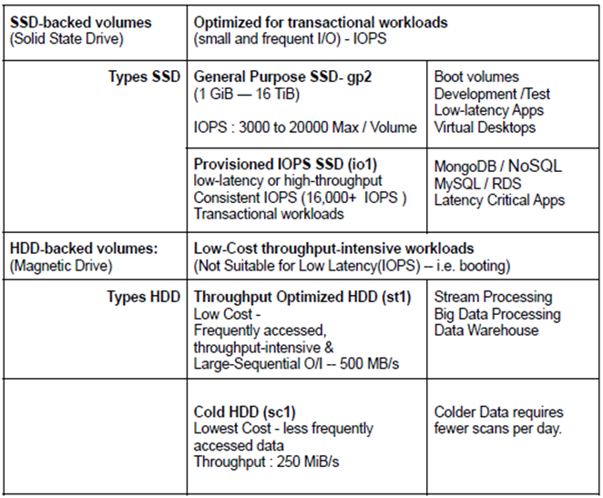

**Instance Store:**

Instance store is the ephemeral **block-level storage for the EC2 instance**.

* Instance stores can be **used** for **faster processing and temporary storage of the application.**

**AMI:**

AMI Stands for **Amazon Machine Image**.

* AMI **decides** the **OS**, **installs dependencies, libraries, data of your EC2 instances**.
* **Multiple instances** with the **same configuration can be launched using a single AMI**.

**Security Group:** A **Security group acts** as **a virtual firewall** for **your EC2 Instances**.

* It decides the type of port and kind of traffic to allow.
* Security groups are active at the instance level whereas Network ACLs are active at the subnet level.
* Security Groups can only allow but can’t deny the rules.
* The Security group is considered stateful.
* By default, in the outbound rule all traffic is allowed and needs to define the

inbound rules.

**Key Pair:**

A key pair, **consisting** of a **private key** and a **public key**, is a **set of security credentials that you** can **use to prove your identity** while **connecting to an instance**.

* Amazon **EC2** instances **use** **two keys**, **one** is the **public key** which is **attached**

to **your EC2 instance**.

* Another is the **private key** which **is with you**. You **can get access** to the **EC2**

**instance** only **if these keys get matched**.

* **Keep the private key in a secure place**.

**Tags:** Tag is a **key-value name** you **assign** to your **AWS Resources**.

* **Tags are the identifier of the resource**.
* **Resources** can be **organized well using the tags**.

**Pricing:**

* You will get different pricing options such as On-Demand, Savings Plan,

Reserved Instances, and Spot Instances.

Step-by-Step Guide : How to create AWS Account ?

* The creation process of an **AWS account.**
* Click the  URL à <https://aws.amazon.com/free> .
* Click on the button on the top right **Create an AWS Account.**

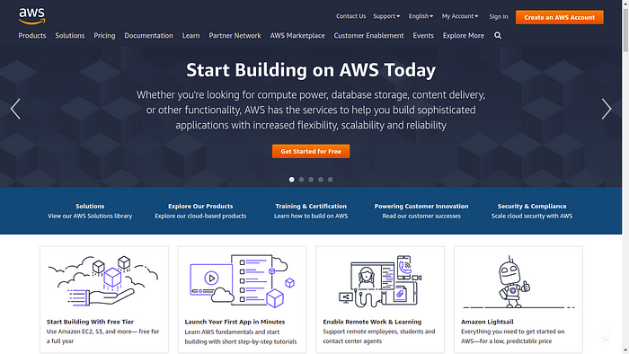

Enter the valid required details like Email address, Password and AWS account name. Then click **verify email address**.

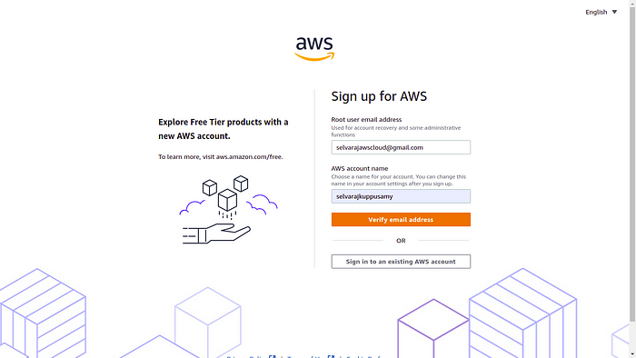

Check respective email. After receiving verification code, to copy the verification code.

Verification code from email

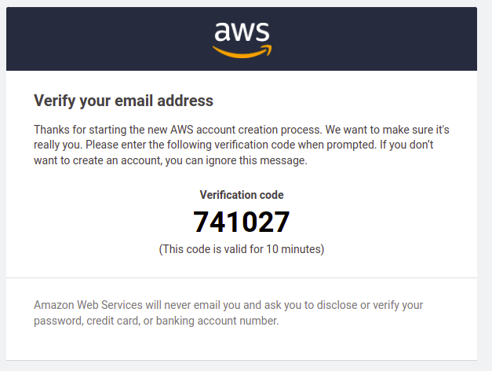

Fill the verification code and Click **Verify**.

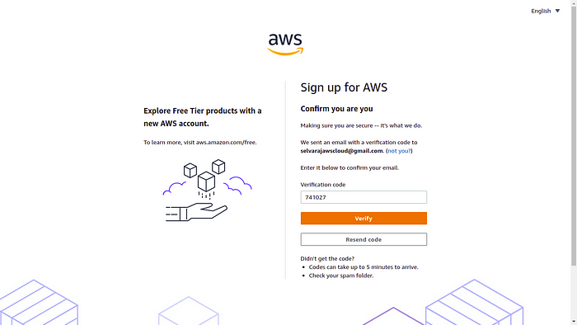

Email address has been successfully registered. Then set Root user password. Then **Continue.**

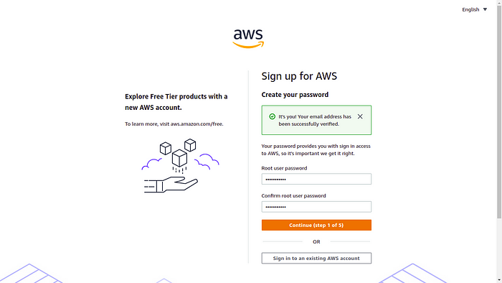

Now, the registration process will ask your Personal Information. you should enter the valid Information.

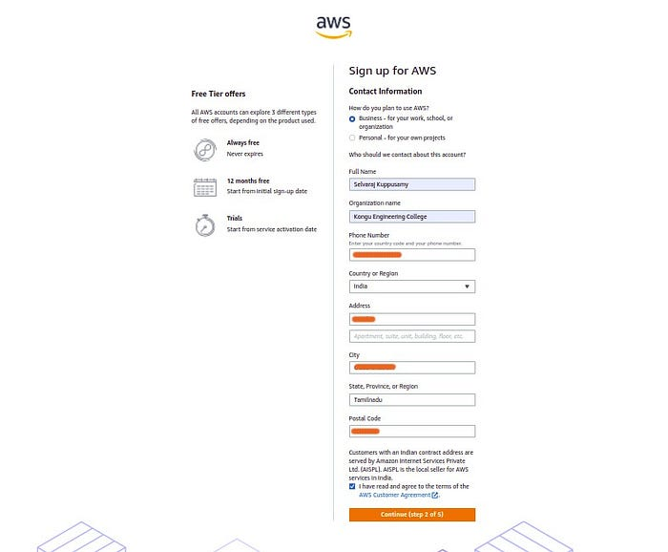

Now, you will provide your payment information. Don’t worry about charges right now.

According to AWS:

* Please type your payment information so, we can verify your identity. We will not charge you unless your usage exceeds the [AWS Free Tier Limits](https://aws.amazon.com/free/)
* In fact, depending on your credit card or debit card company, may be AWS could charge you about **USD $1.00** to check if it is a valid credit card or debit card. They usually undo this charge later.
* Click **verify and continue.**

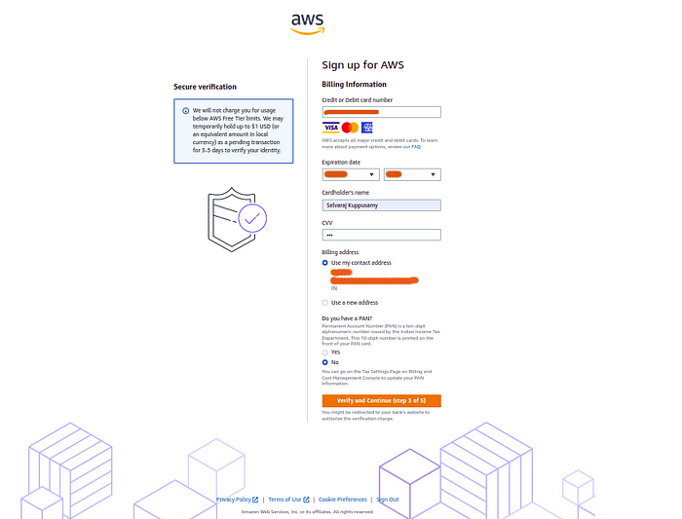

Processing the payment process.



One Time Password will send the respective phone number.

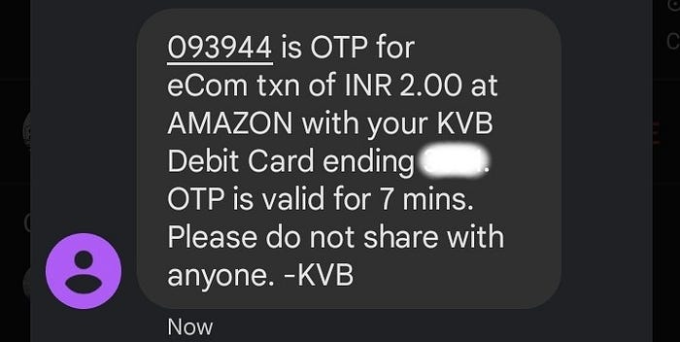

One Time Password from phone

Now, Enter the one time password in respective **bank**page. and then submit.

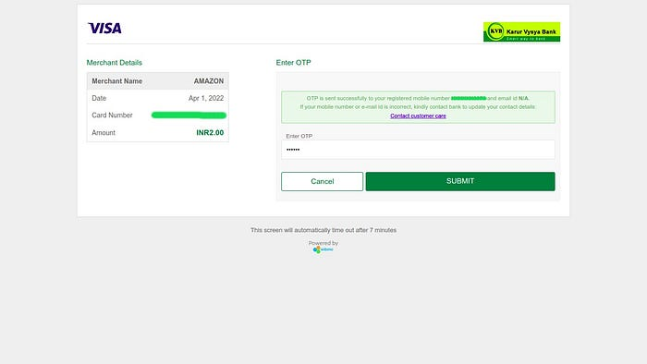

Payment Confirmation

Now you have to confirm your identity to activate your account. You can choose an Text message(SMS) or a Voice call to receive the verification code. And also presented with a CAPTCHA, enter the displayed code, and then **send**.

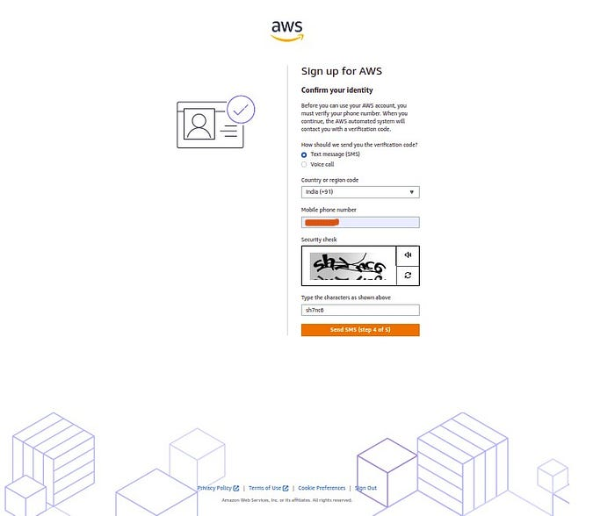

Click on the **Send** button to continue. After the Verification send to Respective phone number.

In my case, I choose Text message(SMS). After receiving verification code, to copy the verification code.

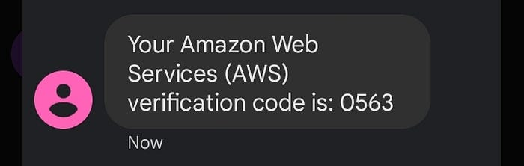

Verification code from phone

Fill the verification code and Click **Continue**.

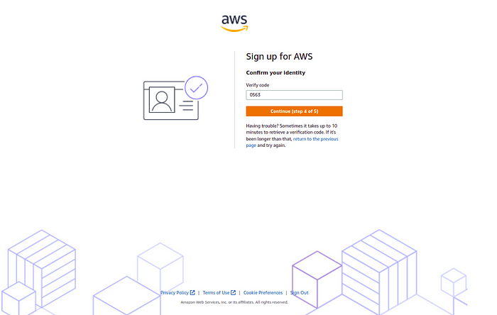

On the Select a support plan page, choose one of the available Support plans.

You can start with the**Basic support - Free.** I strongly recommend reading about the Support Plans to be aware of what each one covers.

In my case, I choose **Basic support - Free.**

Then, Choose **Complete sign up**.

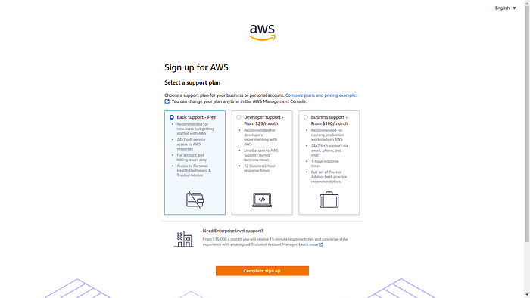

**Amazon Web Services** account has successfully created. Click **Go to the AWS Management Console**.

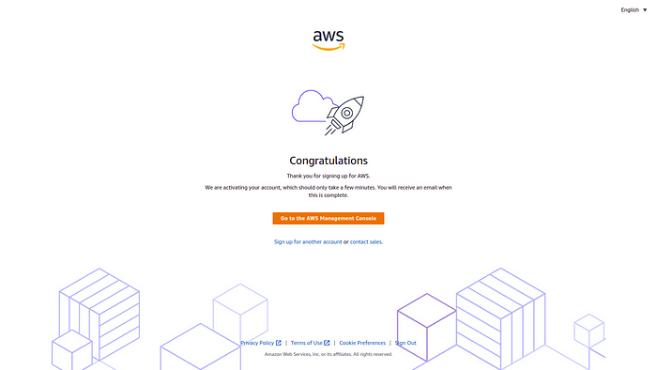

AWS account created page

Now, Enter your Personalize Your Experience. Click Submit.

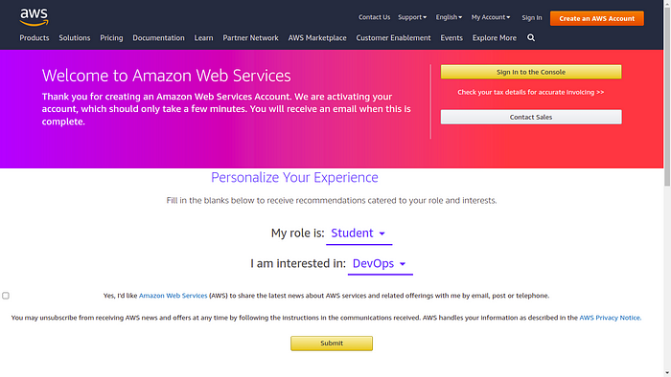

Amazon Web Services page

Click **Sign in to the Console.**

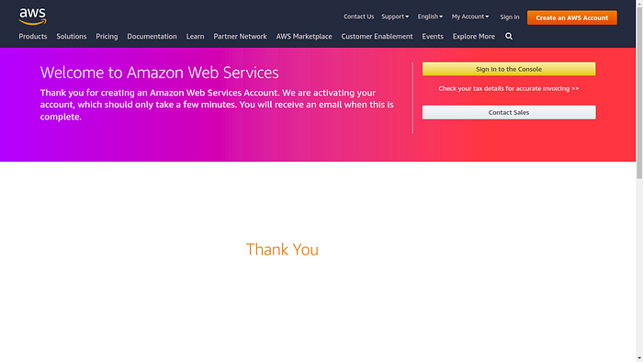

Amazon Web Services Page

Choose **Root user**and enter registered email and then click **Next.**

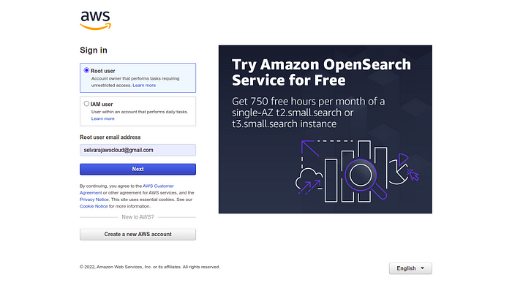

Sign in of AWS

If presented with a CAPTCHA, enter the displayed code, and then click **Submit**.

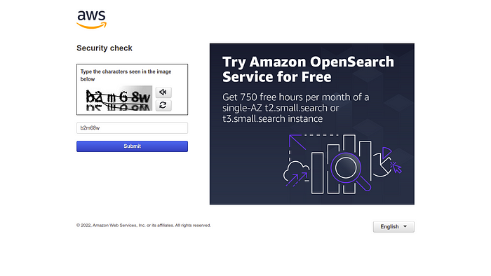

Sign in of AWS

Enter the root password and click **Sign In.**

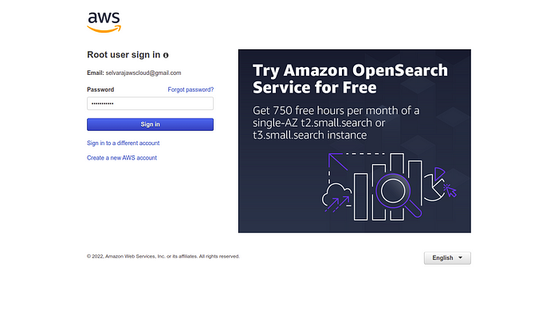

Sign in of AWS

Now, **Amazon Web Services** account has successfully logged in. 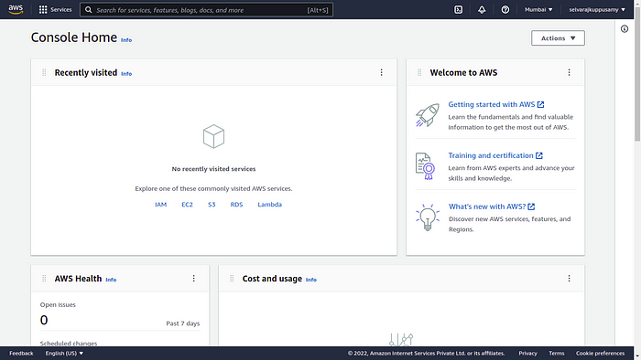

Amazon Web Services Page

Explore **All services**.

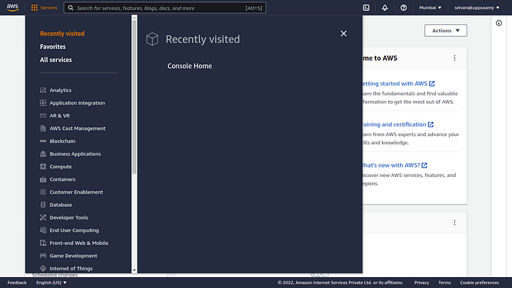

Step-by-Step Guide: Creating an EC2 Instance in AWS

Creating an EC2 instance

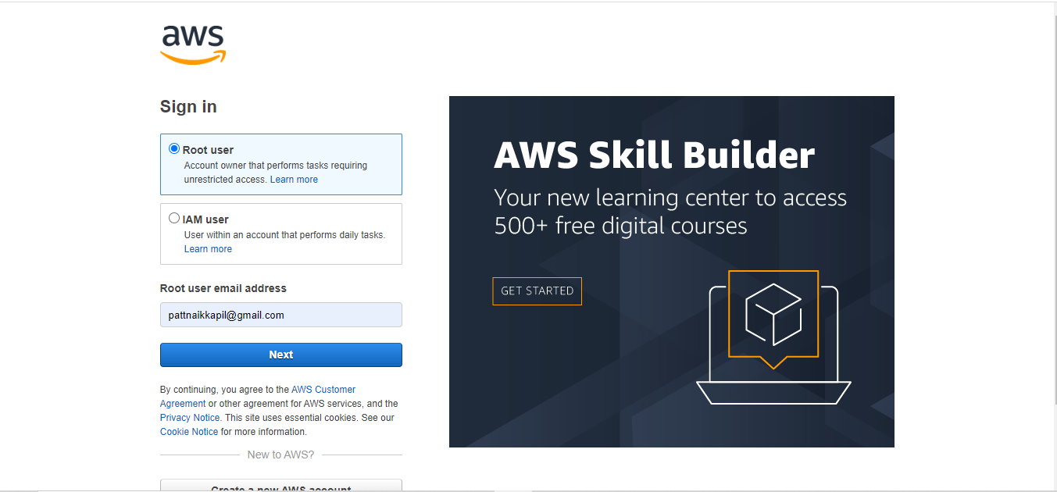

**Step 1: Sign in to the AWS Management Console**

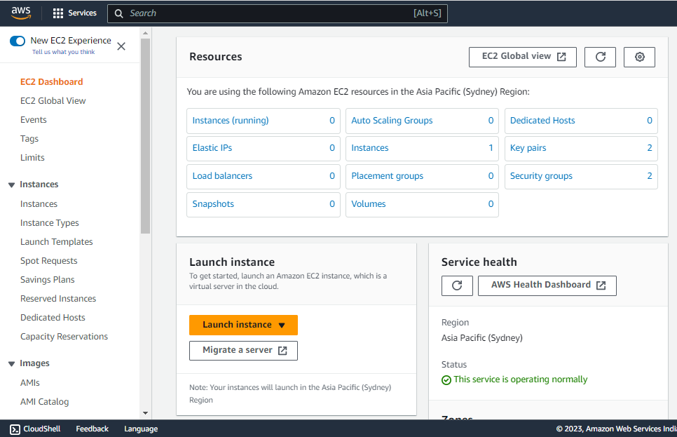

**EC2 dashboard**

To create an EC2 instance, you first need to sign in to the AWS Management Console. If you don't already have an AWS account, you'll need to create one. Once you're signed in, navigate to the EC2 dashboard and Launch an instance.

**Step 2: Choose a name of your instance**

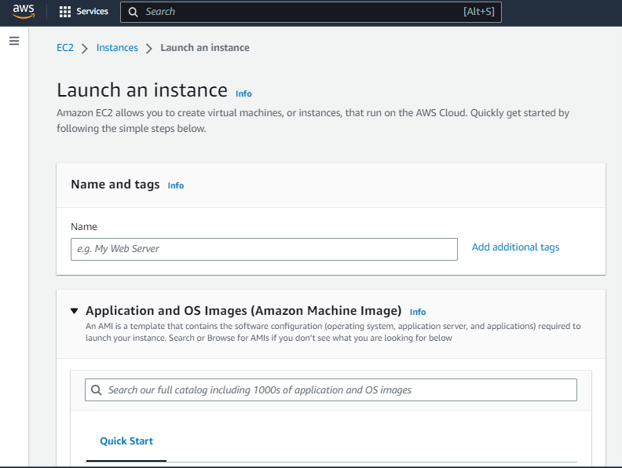

Select a name of your instance as per your wish

**Step 3: Choose an Amazon Machine Image (AMI)**

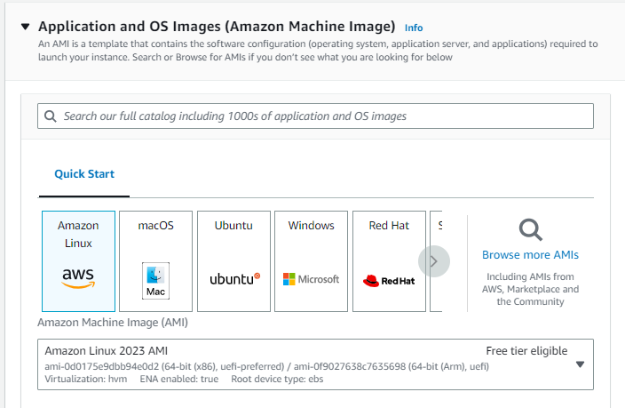

**Selecting AMI for your instance**

An Amazon Machine Image (AMI) is a pre-configured virtual machine that serves as a template for your EC2 instance. You'll be prompted to choose an AMI from a list of available options. You can choose from Amazon Linux, Ubuntu, Windows, and many other options.

**Step 4: Choose an Instance Type**

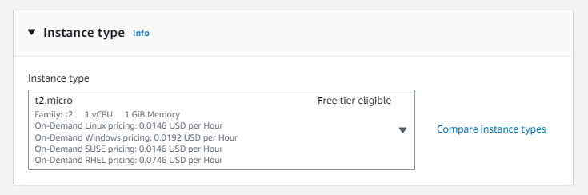

An instance type determines the computing resources (CPU, RAM, storage, etc.) available to your EC2 instance. There are a variety of instance types to choose from, ranging from small and low-cost to large and high-performance. Select the instance type that best fits your needs and budget.

**Step 5: Create a key pair**

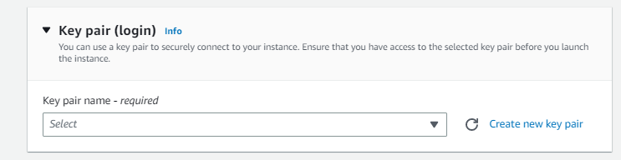

Create a key pair if you have never created one and store it in a safe place because it will act as a key to log in to your instance.

**Step 6: Configure Security Group**

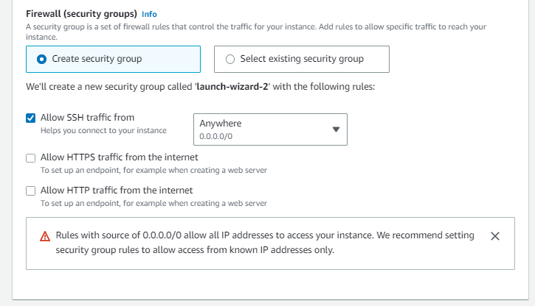

Security groups act as virtual firewalls for your EC2 instance, controlling inbound and outbound traffic. You can configure security groups to allow or deny traffic from specific IP addresses, protocols, and ports. In this step, you'll need to create a new security group or select an existing one.

**Step 7: Add Storage**

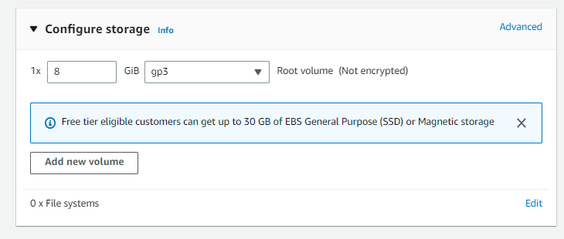

EC2 instances require storage for the operating system, applications, and data. In this step, you can add and configure storage volumes for your instance. You can choose from different types of storage, including Amazon Elastic Block Store (EBS) volumes and instance store volumes.

**Step 8: Review and Launch**

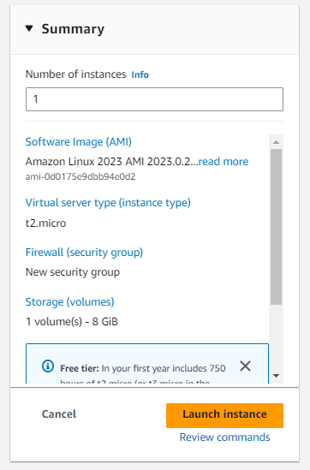

Before launching your instance, review all the details to make sure everything is correct. You can also modify any settings that need to be changed. Once you're ready, click the "Launch" button to start your EC2 instance.

**Step 9: Connect to Your Instance**

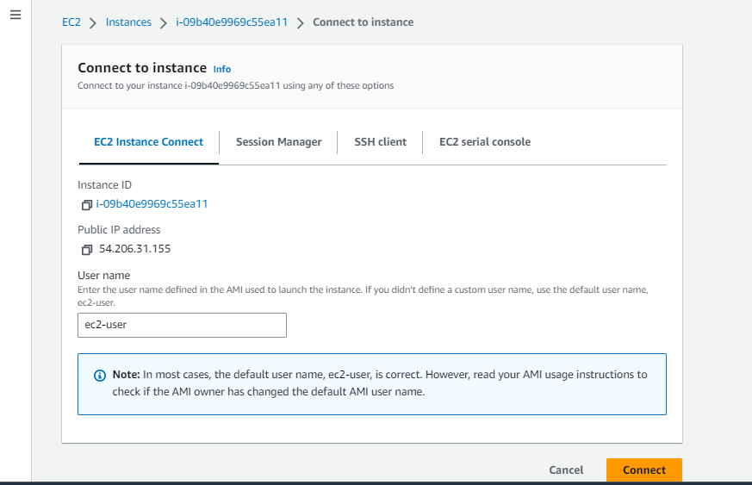

After launching your instance, you can connect to it using various methods, such as SSH or Remote Desktop Protocol (RDP). You can also use the AWS Systems Manager Session Manager to connect to your instance securely without the need for a public IP address.

### **Conclusion**

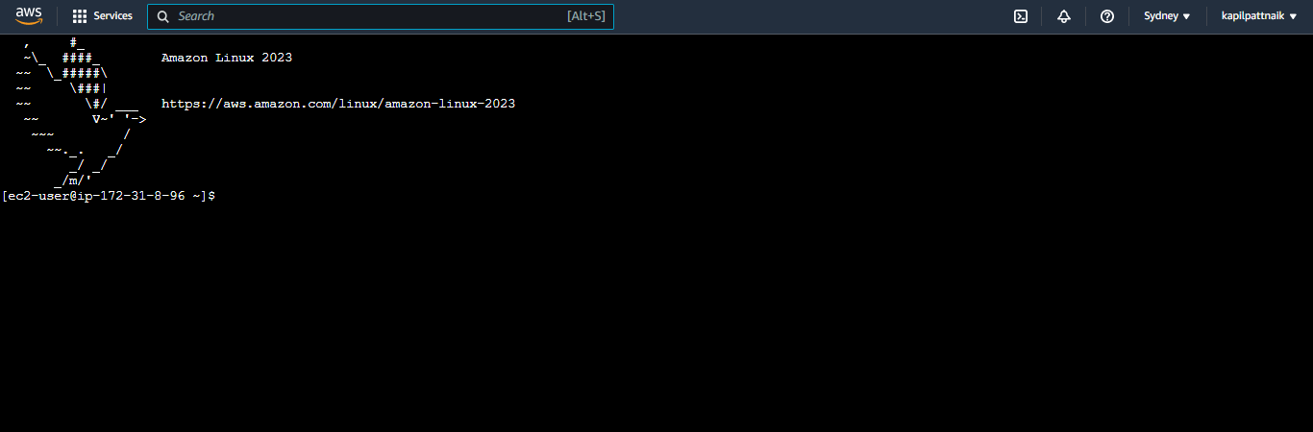

Creating an EC2 instance in AWS is a simple and straightforward process. With just a few clicks, you can launch a virtual machine in the cloud and start using it right away. By following the steps outlined in this guide, you can create your own EC2 instance in no time.